Gloeocapsa sp. 1948 Kützing 1843

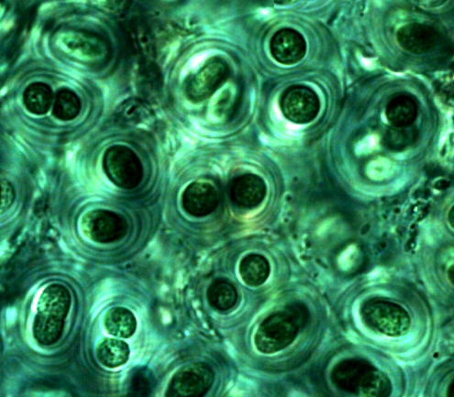

Phylum: Cyanobacteriophyta
Class: Cyanophyceae
Order: Chroococcidiopsidales

Habitat: benthic, on stones in shallow waters
Distinctive features: Rare species of multicellular mucilaginous, amorphous colonies, made of spherical to ovoid cells in multiple envelopes, seen macroscopically as small blue-green aggregates.
Organization: colonial
Color: blue-green
Cell shape: sphere
Colony shape: irregular
Cell diameter (D): ~ 5 μm
Cell biovolume: ~ 65 μm³
Biovolume equation: sphere, V = 4/3 π (D/2)³.
Cells per colony: many
Morphological features:
Multicellular mucilaginous, amorphous colonies, made of spherical, subspherical or hemispherical (after division) cells in multiple envelopes that do not copy exactly the cell shape. Cells with homogeneous blue-green content (Plates 1, 2). Cells and their immediate groups are surrounded by lamellated envelopes.

Plate 1. Gloeocapsa sp. from the littoral zone of Lake Kinneret. Photo by Alla Alster, Oct. 2006.

Plate 2. Gloeocapsa sp. from the littoral zone of Lake Kinneret. Photo by Alla Alster, Dec. 2006
Ecology:
A rare benthic species that occurs only in the littoral zone. When present, colonies are large enough to be seen macroscopically as strongly colored blue-green aggregates on stones in the shallow water.

Cite this record as:
Tamar Zohary, Alla Alster. [Date when Item was last updated]. Electronic publication. Israel Oceanographic & Limnological Research. [Date when last accessed].

